Change Mgt:

Network Configuration Request Form

Introduction:
This document describes on how to fill the network configuration request form for the NCR Team to perform Add Mainframe Printer Gen , Change Mainframe Printer Gen and Delete Mainframe Printer Gen requests.

Details:
- Go to the Network Configuration Request Form.
Request Information
- Select the Function Field and choose either Add, Change or Delete. This is based on the which type of Printer Gen IMAC is received.
- Select Printer in the Item field.
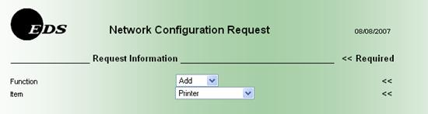
Requestor Information
- Enter all required field stated below.
  - Requestor Name (Last Name, First Name)
  - Requestor Phone Number
  - Requestor Email Address
  - Backup Name (Last Name, First Name)
  - Backup Phone Number
  - Backup Email Address
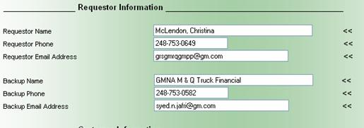
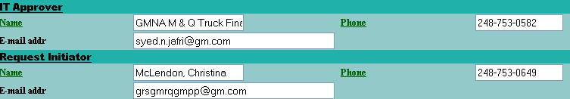
Note:
- All information about the Requestor can be found in the GRS Archive Viewer under the Request Initiator Section
- If backup information is not provided in the GRS Archive Viewer or is the same as the Requestor information, enter NA in all Backup fields.
Customer Information
- Enter all required field stated below.
  - Customer Name (Last Name, First Name)
  - Customer Phone Number
  - Customer Email Address
  - Account Name (Enter user's EDSNET ID)
  - Service Location Address (Enter Location and Building Name)
  - City
  - State
  - Zip
  - Moc: Response Center (The information for this field can be located in Service Center IMAC Description Field)
Note:
  - For City, State and Zip Code information, reference Account Profile
  - First Fill up the MOC # , followed by the RC #. The first 4 digits need to be filled up in the second column and in the 3rd column, the last 3 digits needs to be filled
Communication and Specifications
- The Communication and Specification Section should not be edited.
Mnemonic / Complex-Image
- Enter the Mnemonic field with the Application Mnemonic Name. In the example above, the Application Mnemonic Name is IMPE - P404/B2ims
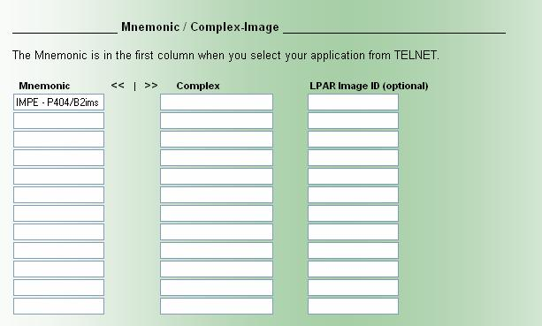
Terminal Information
- Enter fields state below only.
  - Quantity (Based on the IMAC Quantity provided)
  - Port Addr (Information to be provided in GRS Checklist)
  - LTerm/Termid (Information to be provided in GRS Checklist)
IP Information
- The IP Information Section should not be edited.
CA/SPOOL or VPS Printer
- Enter all required field stated below.
  - Printer Software (Select either CA/SPOOL or VPS)
  - Printer Protocol (Select IP or VPS)
  - Printer Address (Enter printer IP address based on the information provided under the IPVP Address in the GRS Checklist)
  - Vendor/Name/Model (Enter the printer make based on the information provided under the PrinterManuf field in the GRS Checklist)
  - Port Address. (Enter NA)
  - PCL Support (Select Yes)
  - Impact/Matrix Printer (Select No)
  - Orientation (Select Automatic)
  - Separator/Header Pages (Select No)
Note:
  - For Printer Software, the option chosen needs to correspond with the information provided under the Printer Software in GRS checklist .
  - For Printer Protocol , the option chosen needs to correspond with the information provided under the Printer Protocol in the GRS checklist.
  - Line Limit, Model After Printer, Special Parms Requested and VPS Billing Access should not be edited.
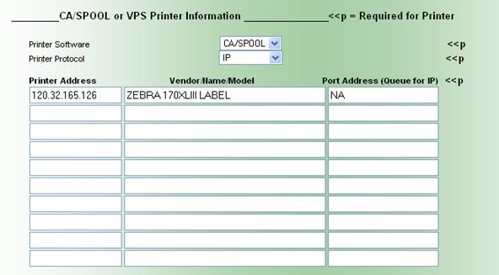
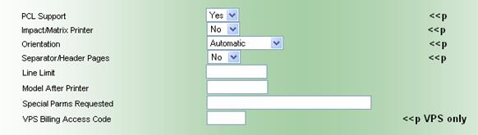
Comments
- Copy and paste the all information provided in the GRS Checklist.
- If a special instruction is provided, paste the information in comments section.
- If an attachment is provided, attached it in the comments section.
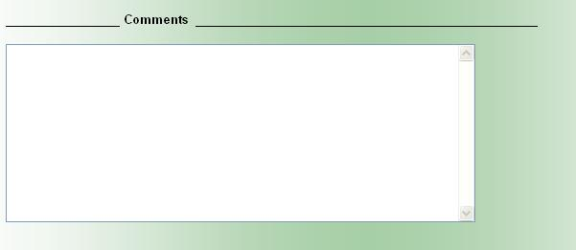
- Next, Click on the button.
- Once the submit button is clicked, it will prop up your email to send a letter to the NCR Request Inbox and the Request Handler needs to CC the Request Manager with the below title.
- Title of Subject should be Network Configuration Request // IMAC # / GRS number
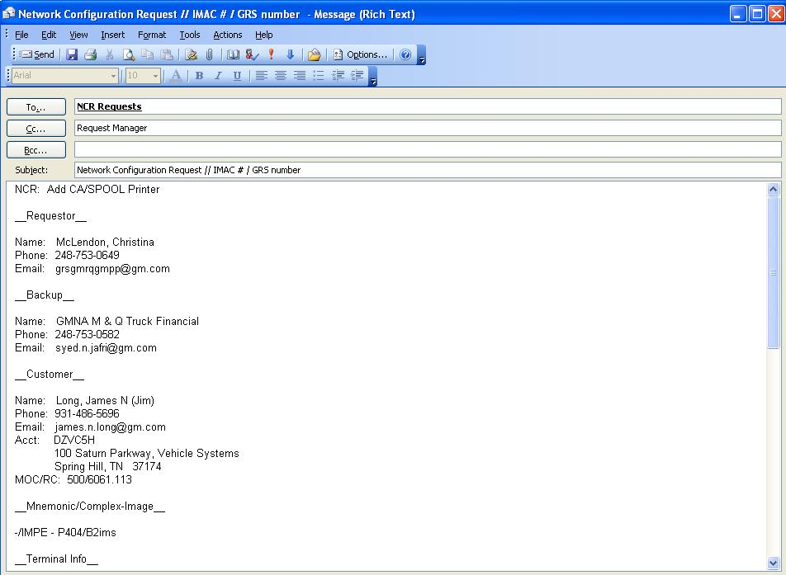
- Once the email has been sent, the Network Configuration Request (NCR) team will respond back to the email within 24 hours, providing the Request Manager with the Incident Ticket number. E.G. 100-01-XXXXXXX
- The Request Manager who manages the IMAC ticket number will input the Incident Ticket number in the Services Line Item of either the Add Mainframe Printer GEN, Change Mainframe Printer GEN and Delete Mainframe Printer GEN IMAC.
- Once the NCR Team have completed their portion of the request, they will notify the Request Manager by sending an email stating that the work is completed.
- Request Manager will proceed with the Close Change Request process.

Additional Information:
If you see <<p , it means that the field is a required field for printer.
If you see << , it means that the field is a required field

Exceptions:

