
PCI HP Admin Access via SNX
hp.com

>>
Payment Card Industry
HP Access via SNX
For all US PCI sites
Version# 0.3 – DRAFT

12 Oct 2010

Contents
1 Document Controls 3
1.1 Statement of Confidentiality 3
1.2 Change History 3
1.3 Referenced Documents 3
1.4 Referenced Sites 4
2 Introduction 5
3 Preliminary steps to ensure connectivity 6
3.1 PCI Onboarding Process 6
4 Establish SNX gateway connectivity 7
4.1 Open browser and enter the gateway’s URL 7
4.2 SNX Checking Status 8
4.3 Undergo two-factor authentication 8
4.4 Ensure that the gateway’s icon is active on the task bar. 10
5 Launch your administrative tools and communicate with your desired PCI destination. 12
6 Ending your SNX gateway connectivity 13
Appendix A – HP Autocache Workaround 14

- Document Controls
  - Statement of Confidentiality
All information in this document is HP Confidential. This information is not to be discussed with or disclosed or distributed to any person who is not an HP employee or whom HP has not authorized to receive it.
  - Change History
The following Change History log contains a record of changes made to this document.
Published / Revised Date | Version # | Author  (optional) | Section /  Nature of Change
12 Oct 2010 | 0.1 | Marc E Mandel | Initial draft
12 Oct 2010 | 0.2 | Marc E Mandel | Fixed SNX DNS entries. Added more details to 4.2 and 6. Changed Permeo to SNX in Appendix A.
26 Oct 2010 | 0.3 | Rachel Snyder | Removed SNX URLS with PCI, minor wording updates.

  - Referenced Documents
Document Name | Embedded Referenced Documents
User_Guide_ for PCI Remote Access v1.6.doc | 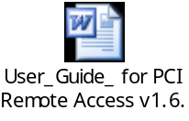

  - Referenced Sites
Site Name | URL
New SNX gateways | Auburn Hills  https://usahspcig002.ssn.hp.com/  Charlotte  https://usclspcig002.ssn.hp.com/  Plano  https://usplspcig002.ssn.hp.com/  Sacramento  https://ussaspcig002.ssn.hp.com/
Retained Permeo gateways | Auburn Hills  https://usahspcig001.miabh.us.eds.com/pci/  Charlotte  https://usclspcig001.ncchr.us.eds.com/pci/  Plano  https://usplspcig001.txpln.us.eds.com/pci/  Sacramento  https://ussaspcig001.casac.us.eds.com/pci/
PCI Token Process | http://intranet.hp.com/eds/ww/wg/GIS/SA/Pages/pci_token_process.aspx

- Introduction
This document covers Payment Card Industry (PCI) Hewlett-Packard (HP) administrative using the new SNX gateways that are replacing the end-of-life Permeo gateways in the following PCI Control compartments:
- Auburn Hills
- Charlotte
- Plano
- Sacramento

Each of the four sites listed above will operate for a short period with one news SNX gateway and one retained Permeo gateway. The SNX gateway is a Check Point Integrated Appliance Solutions (IAS) M2 firewall appliance with the SSL Network Extender (SNX) software blade at release 71 (R71). The M2 appliance is a rebranded HP D2 server platform. The retained Permeo gateway is a Permeo Technologies (acquired by Blue Coat Systems) Secure Application Gateway (SAG) running on a Sun platform.

To get to any PCI destination, an HP administrator must undergo two-factor authentication (2FA) at either the new SNX gateway or the retained Permeo gateway in order to comply with PCI Data Security Standard (DSS) requirements.

- Preliminary steps to ensure connectivity

To ensure connectivity, the following must be carried out once before you attempt your initial connection to either the SNX or Permeo gateway.

  - PCI Onboarding Process

In order to use either gateway, you need to be onboarded to the leveraged HP Enterprise Services US Payment Card Industry (PCI) privileged user provisioning infrastructure.

To initiate PCI onboarding, you need to have your home group’s NACOS administrator assign your HP Global ID (=ZID) to the PCI application PCIUSR00. This will trigger emails to you regarding obtaining and activating your PCI two-factor authentication token. If you already have a token for SDN access, that token can also be used for PCI access. When completing the token request, enter the serial number found on the back of your existing token into the appropriate field on the online request form. It is also advisable to enter “Use token serial number #########” in the street address field to prevent a second token being mailed to you. For ##########, enter the actual serial number. Following the completion of the online token request form, since PCI access can support multiple client accounts, your home manager will be emailed to approve the cost of a new token (if required) and the monthly support fee. Following your manager’s approval, you will be emailed instructions to activate your token within the PCI environment. The SDN token management solution and the PCI token management solution are independent from each other. Thus they each require separate activations. You can select to use the same personal identification number (PIN) for both solutions or activate a different PIN for each environment.

For complete details, consult the PCI Token Process web site (see section 1.4 Referenced Sites) and the document User_Guide_ for PCI Remote Access v1.6.doc (see section 1.3 Referenced Document).

If you need assistance with the new SNX gateway, retained Permeo gateway, or PCI token access, consult the Support menu item on the left-hand side of the PCI Token Process web site. As of this writing, the contact information is:

Help Desk support is now available to assist PCI users with 24x7 assistance.

In the U.S.: | 1-888-263-4337, select option 3, then 2, then 5 (RSA Token Support), then option 4 (EDS employees supporting Payment Card Industries).
Outside the U.S.: | 1-972-796-6383, options 3, 2, 5, 4
Asia Pacific: | Credit Services 9011 61 1300 733 727
EDS Aus: | 9011 61 1300 762 337
EDS NZ: | 9011 64 0800 429 439
- Establish SNX gateway connectivity
Activities
- Open browser and enter the gateways’ URL (Section 1.4)
- SNX checking status
- Undergo two-factor authentication
- Ensure that the gateway’s icon is active on the task bar.

If you find that you cannot connect to a destination after carrying out the above activities, you may need to deactivate your browser’s Use automatic configuration script setting before connecting to the SNX gateway. See Appendix A for details.

The new SNX gateway officially supports:
Microsoft Windows XP
Microsoft Windows Vista (32-bit and 64-bit)
Microsoft Windows 7 (32-bit and 64-bit)

The new SNX gateway officially supports:
Microsoft Internet Explorer (IE) 6 (Consider upgrading to IE7 asap)
Microsoft Internet Explorer (IE) 7
Microsoft Internet Explorer (IE) 8

  - Open browser and enter the gateway’s URL
To establish SNX gateway connectivity select the URL of the new SNX gateway at the PCI site you wish to enter.

Note: If the page indicates Done with Errors, try a refresh.

If you get the following Security Alert, select OK.
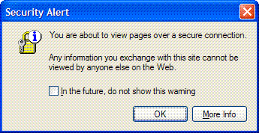

A successful connection will result in the following browser page:
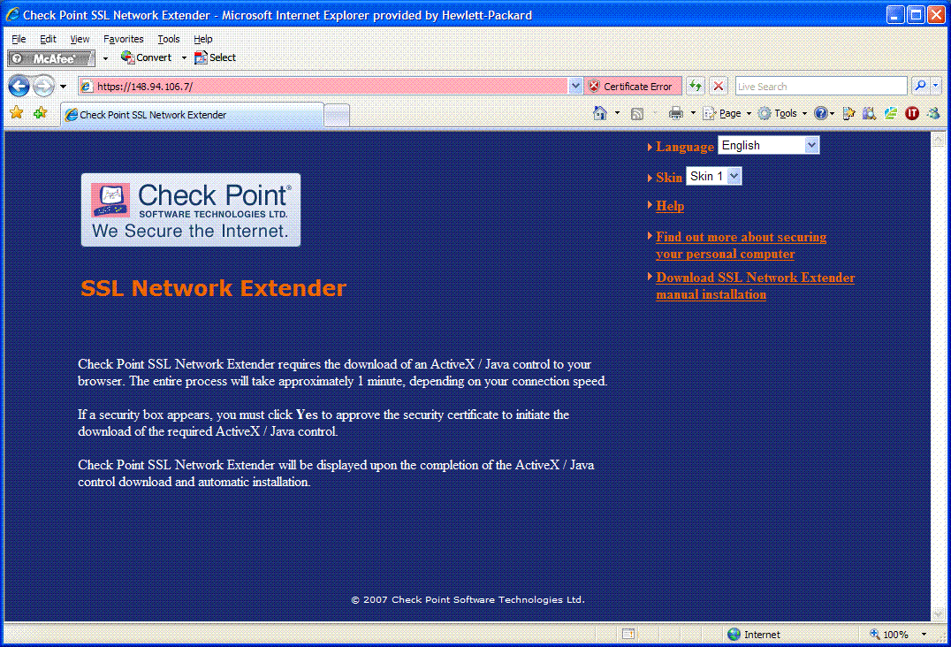

  - SNX Checking Status
After reaching the SNX gateway and obtaining the screen in 4.1 above, you may see the following window pop up prior to being prompted for two-factor authentication. This is the period of time when the SNX gateway is checking the security posture (status) of your workstation.

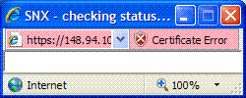

  - Undergo two-factor authentication
After SNX checks the status of the workstation, it will pop up the following separate screen to prompt for the HP administrator’s two-factor authentication.
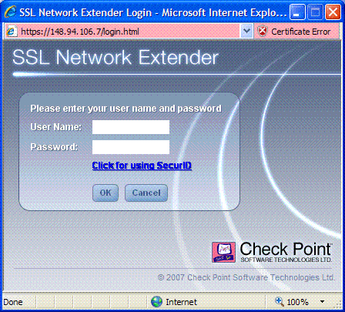

In the User name field, enter your own HP Global ID (=ZID).

In the Password field, enter the PIN you established at activation followed by the current six-digit number being displayed on your token to product a ten digit one-time password. Note that if only one bar or no bar is showing next to the six-digit number, you should wait until a new six-digit number appears first. So if your PIN was 1234 and the current number on the token was 197222, then the entered Password would be 1234197222.

Then click on OK to complete the two-factor authentication.
  - Ensure that the gateway’s icon is active on the task bar.
If you authenticate successfully, then the following SSL Network Extender pop up window will appear.

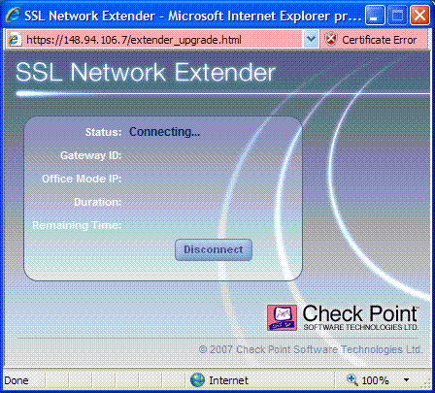

Eventually, the window will show the following screen that the workstation’s SSL VPN tunnel is connected to the gateway. Do NOT close this window or you will terminate the connection that was just established.
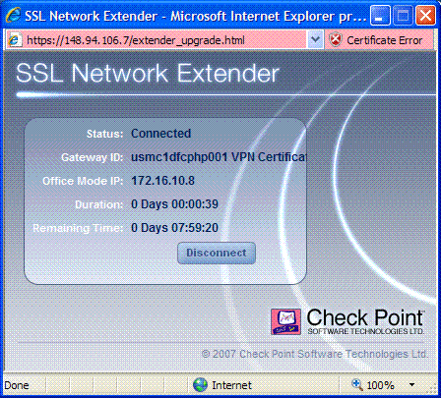

You should minimize the above screen and confirm that the SNX SSL VPN Active Icon appears on your task bar.
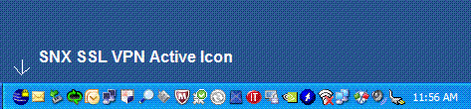

- Launch your administrative tools and communicate with your desired PCI destination.
While the Permeo gateway gave you a menu of permitted tools that you could use, the SNX gateway does not. You simply launch an appropriate tool from your workstation and if the destination and the protocol/port used by the tool are authorized in the SNX gateway rule base, then the connection will be made.

Here are some common tools:

Browser using HTTP (port 80) or HTTPS (port 443)
Microsoft Internet Explorer - C:\Program Files\Internet Explorer\iexplore.exe

Remote Desktop Connection (RDC) using RDP (port 3389)
Microsoft Remote Desktop Connection – C:\WINDOWS\system32\mstsc.exe

Secure File Transfer using SFTP/SSH (port 22)
Ipswitch WS_Professional 12 - C:\Program Files\Ipswitch\WS_FTP 12\wsftpgui.exe

PuTTY’s PSFTP - C:\Program Files\PuTTY\ psftp.exe

Secure Shell (SSH) using SSH (port 22)
PuTTY - C:\Program Files\PuTTY\ putty.exe

TN3270 Emulation using TELNET (port 23) or TELNETS (port 992)
HP TeamTalk - C:\Program Files\Hewlett-Packard\TeemTalk Terminal Emulator\teemtalk.exe

IBM Personal Communications (PComm) – see entries within C:\Program Files\IBM\Personal Communications\private\*.ws

- Ending your SNX gateway connectivity
If no longer needed, close your SNX session by right clicking on the SNX SSL VPN Active Icon that appears on your task bar and select Disconnect.
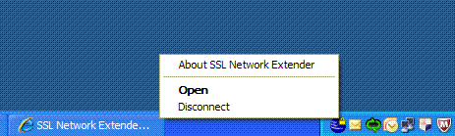

Appendix A – HP Autocache Workaround
If you can reach a PCI destination, then you don't need the workaround.

We found you can two-factor authenticate at the SNX gateway but afterward, when you entered a PCI Data Processing compartment destination, the SNX ActiveX component should direct your IE request through the workstation-SNX SSL VPN tunnel. However, the automatic configuration script was capturing the packet first and attempting to send the traffic to a corporate Blue Coat SG Internet proxy gateway instead.

You may see following Security Alert:

After selecting OK, after a long period, your browser will present the following:
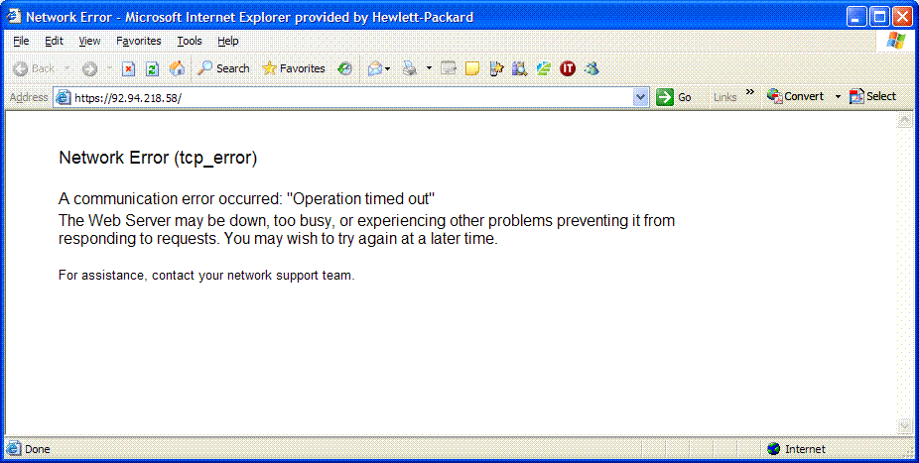

To fix “Network Error (tcp_error) problem, before connecting to the SNX gateway, go into IE and go to
Tools -> Internet Options ... > Connections tab

Select Remote Access to HP Network and then select Settings (see below)
Note that Remote Access to HP Network appears only if you have transitioned to connect from home via HP's network.

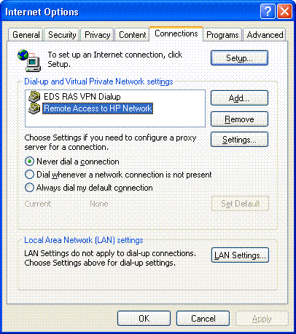

You should see that the Use automatic configuration script is activated:

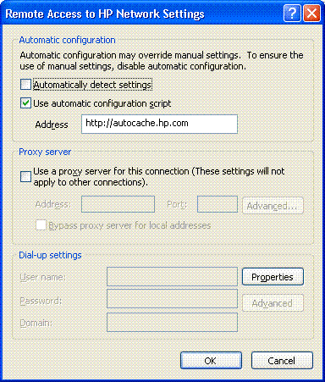

Deactivate the “Use automatic configuration script” setting:

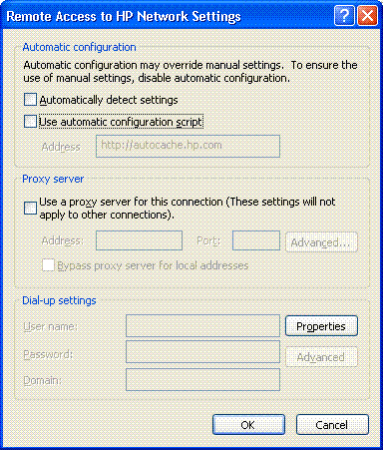

Select the OK on this window and the previous one to enable the change to take effect.

Remember: re-activate this setting when you finish with SNX access so that your traffic to HP, HP Enterprise Services, and Internet sites will work properly.

Also check the LAN Settings… button

See if the Use automatic configuration script is activated.
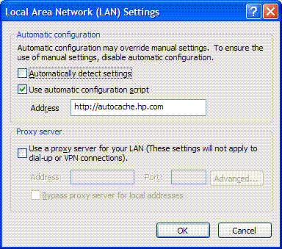
If it is, deactivate “Use automatic configuration script” here as well.
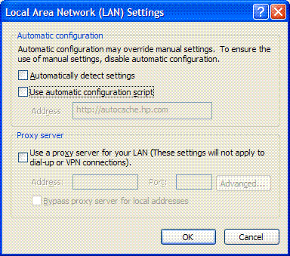
Select the OK on this window and the previous one to enable the change to take effect.

Remember: re-activate this setting when you finish with SNX access so that your traffic to HP, HP Enterprise Services, and Internet sites will work properly.

