The following URL will get you into the usercomms web site.

http://www.ustools.sys.eds.com/usercomms

where you will see the following screen:

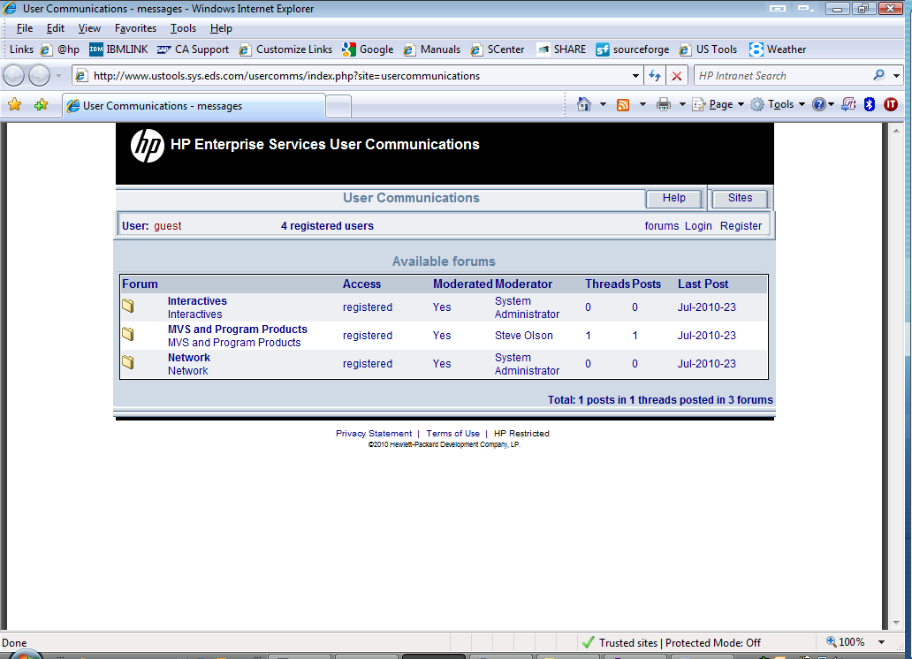

At this point you may browse or search for user communications.
By selecting one of the Forums you will get a list of usercomms.
See the MVS and Program Products forum below.

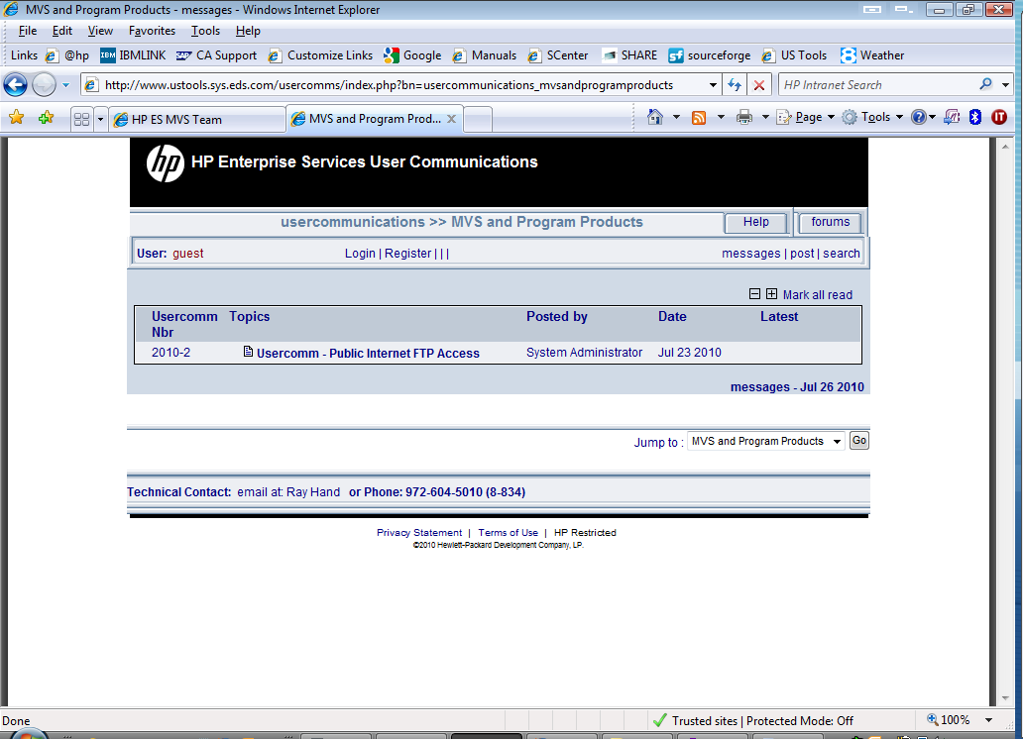

Now select one of the usercomms:

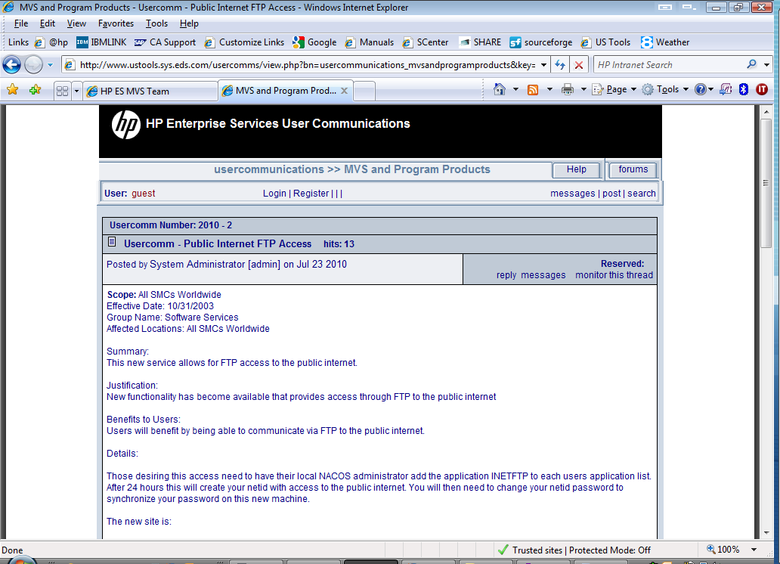

You can also search:

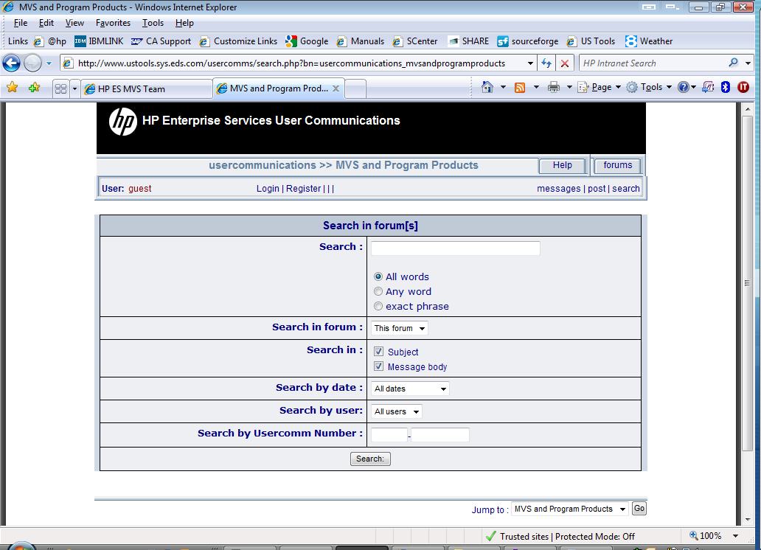

Then you see the results:

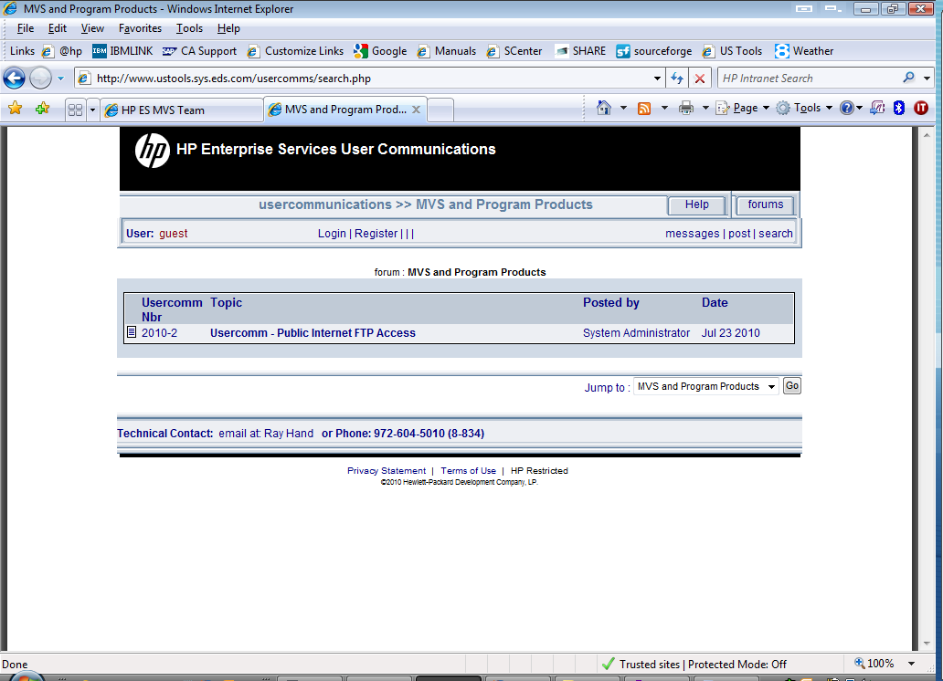

At this point you can then select any of the searched on items.

If you need to do more than search and browse continue on.

If you want email notification of user communications you must continue on to register and subscribe to the usercomms forums of your choice.

Select the register link

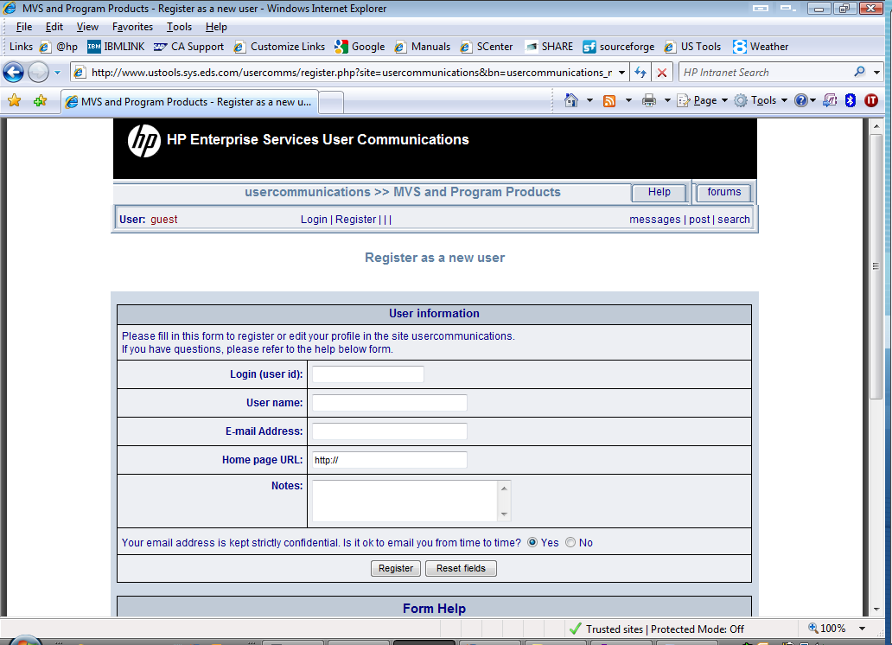

Fill in the userid, user name and email address. Once you click the Register button you will get the following screen.

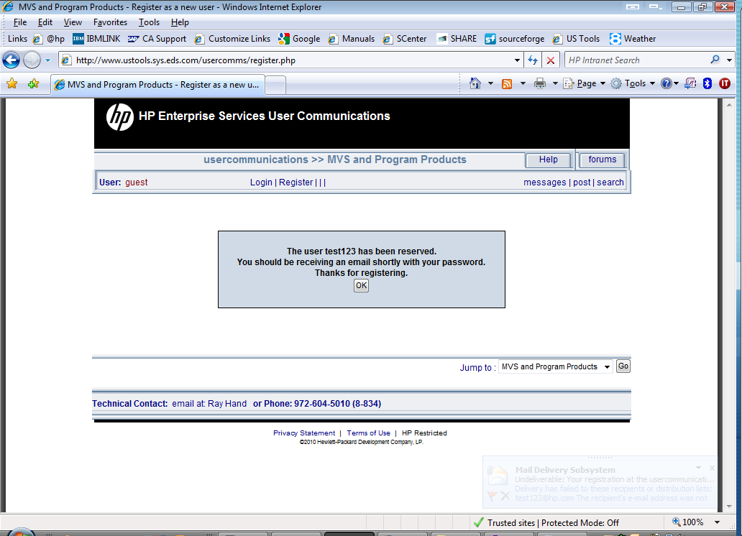

If you have placed the correct email address in the registration you will receive an email with your password. Once you have it copy by highlighting it in mail and using Control C to copy it.

Go to the following url and click on the change password link.

http://www.ustools.sys.eds.com/usercomms/login.php?site=usercommunications&bn=

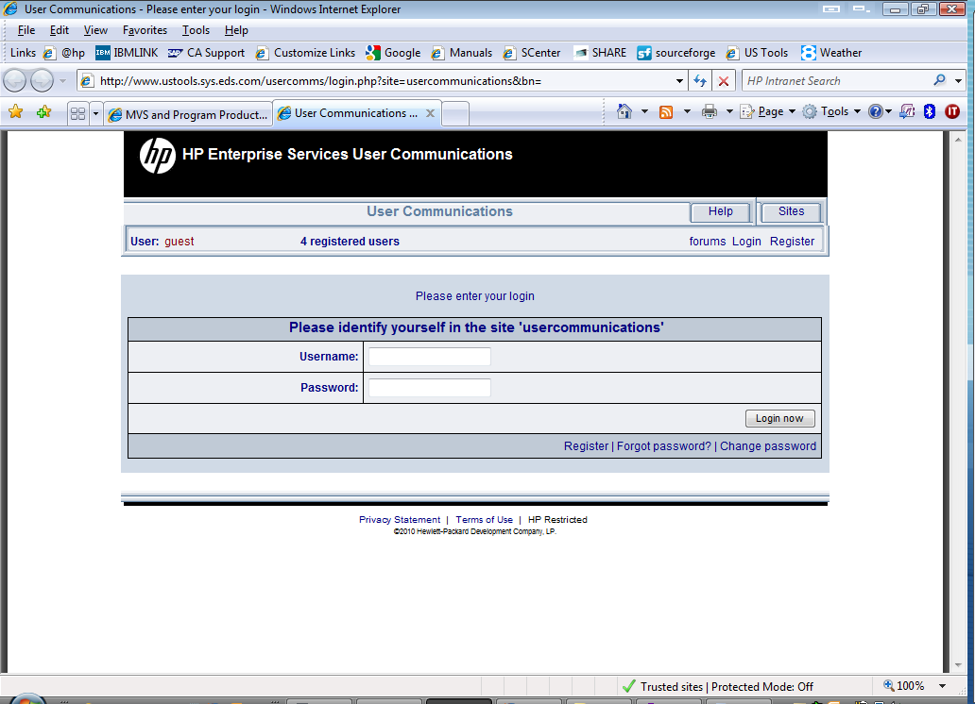

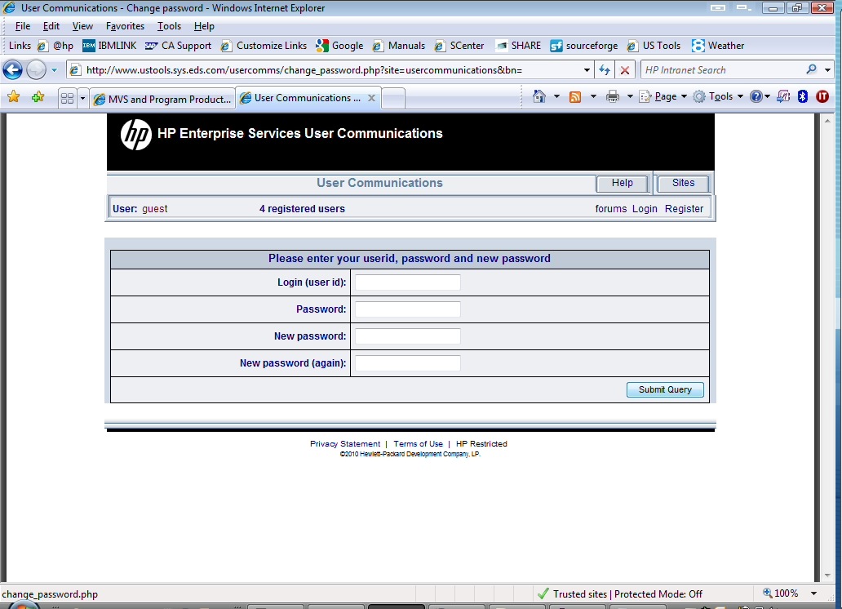

Fill in the form to change your password and press Submit Query.

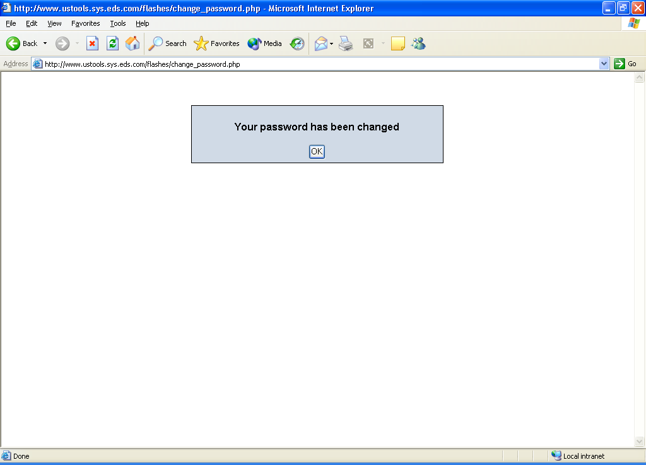

This will take you back to the following screen.

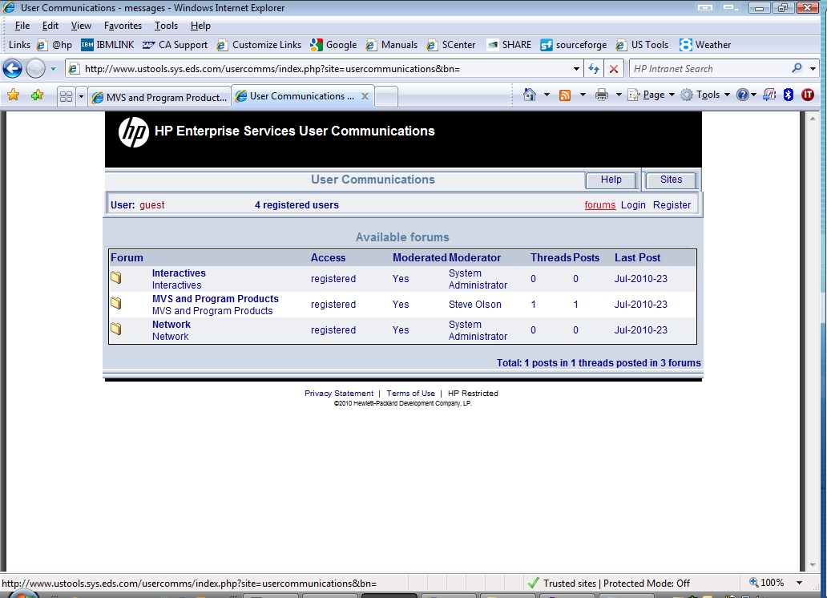

Now click Login.

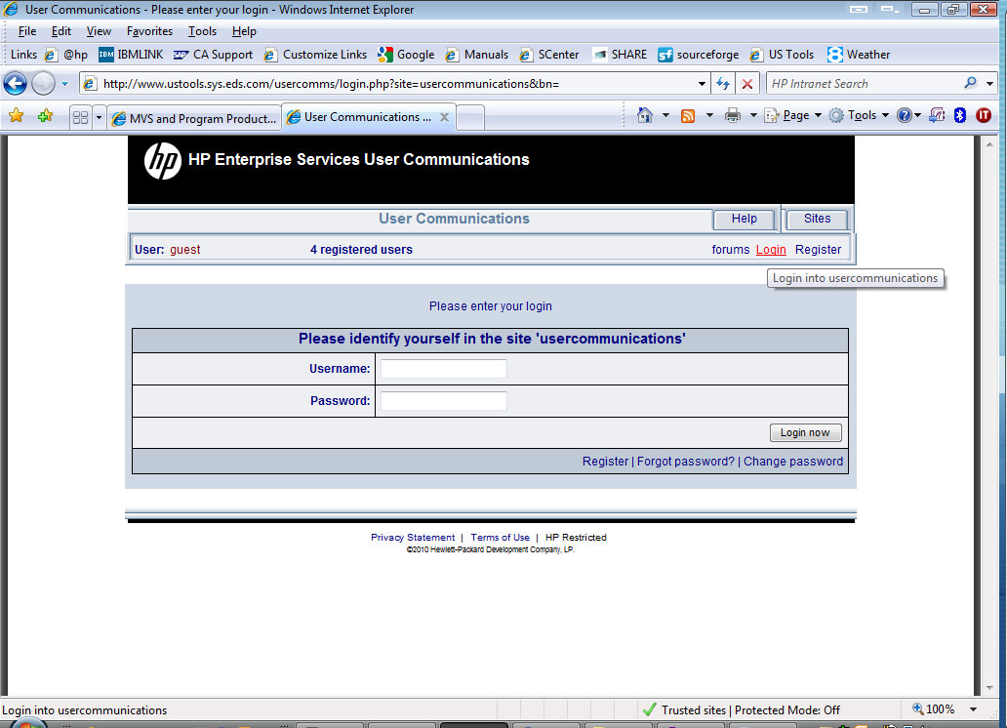

Enter your username and password:

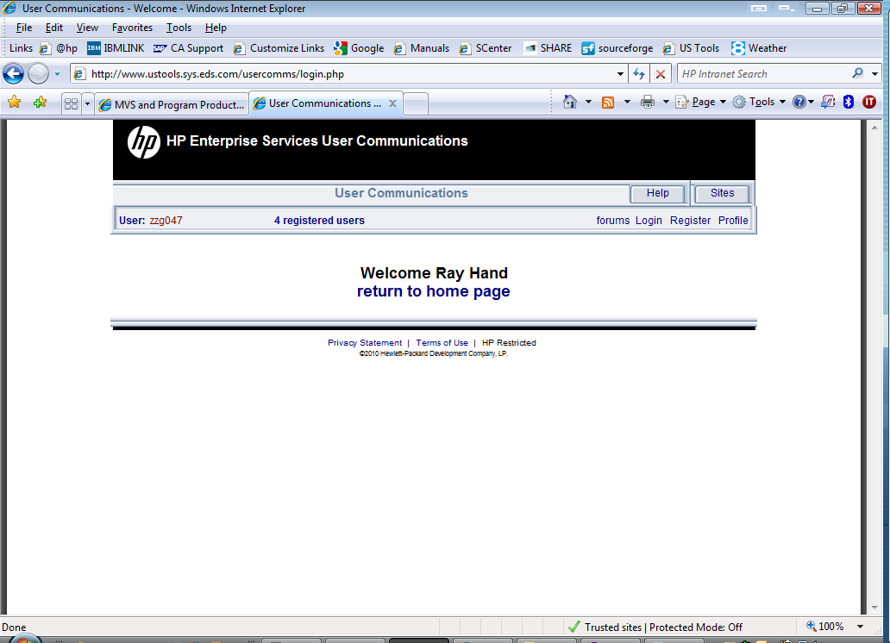

Now select a forum of interest:

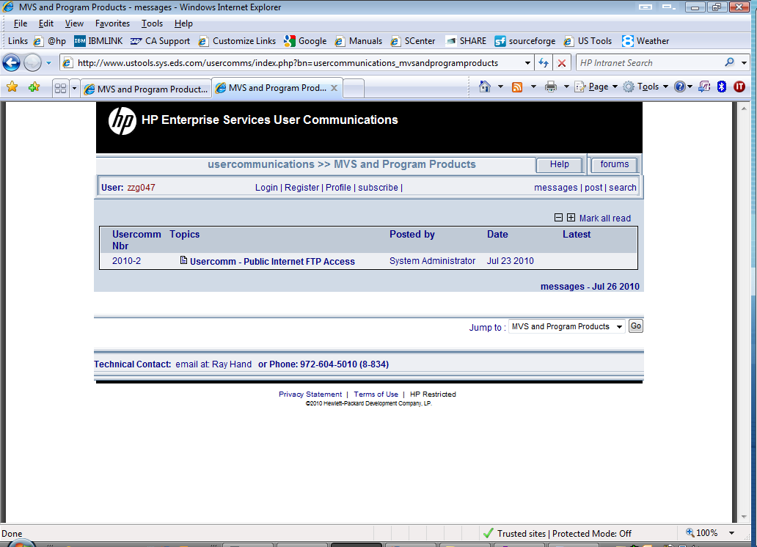

At this point you can subscribe. This will email you when usercomms are approved.
Select the Subscribe link.

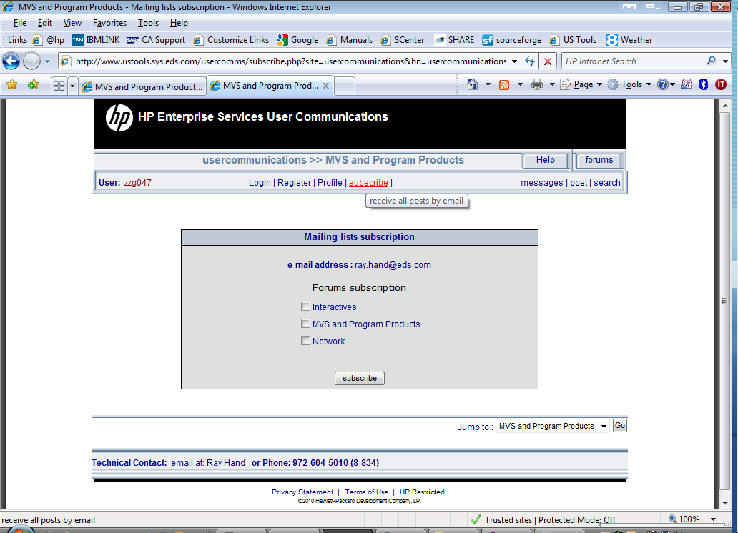
At this point select each forum you would like to receive email notifications from.
Once done select the subscribe button and you will see:

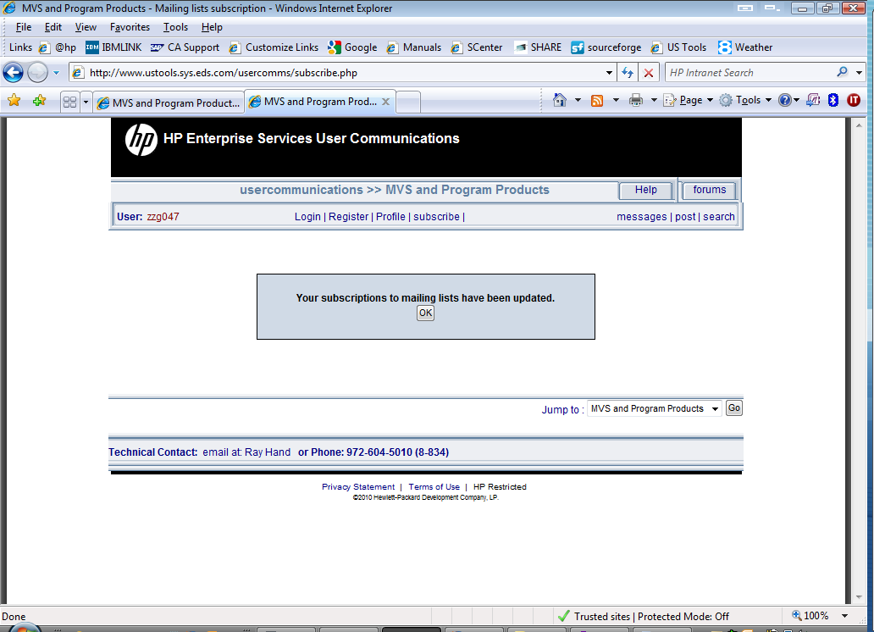

When you select Post you will get :

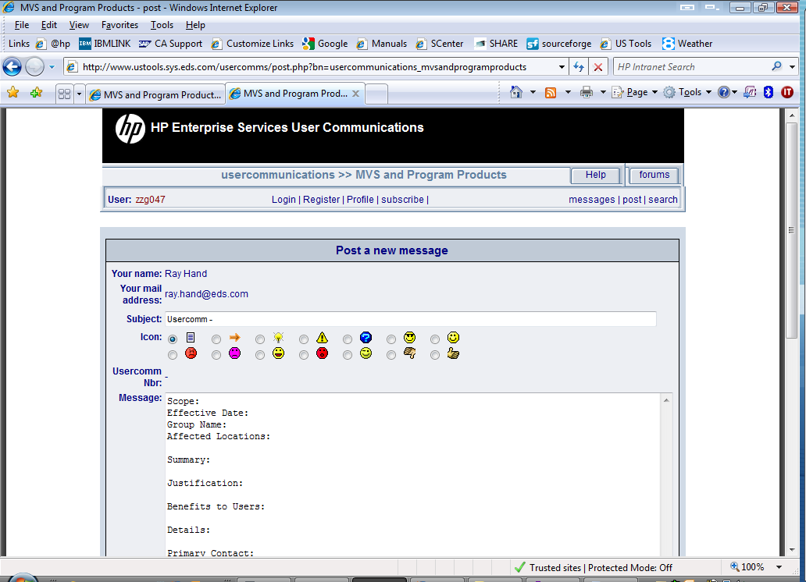

Fill out the user communication and click on the send button.

The approver will need to make the usercomm available at this point.

